3.4 Differentiability

A concept of fundamental importance for the upcoming sections is the notion of differentiability. In Calculus I this concept is discussed in detail in world of 2-space. However, we will need to extend the idea of what me mean by differentiability in Calculus I to better fit the broader context of 3-space.

Motivation:
Recall (From Calculus I): A function is differentiable at if exists. Differentiability in Calculus I was an important concept because it implies several other important properties about :
- has a non-vertical tangent line at .
- may be approximated by a linear function near .
- is continuous at .

In this section we want to extend this notion differentiability to functions of two or three variables such that:
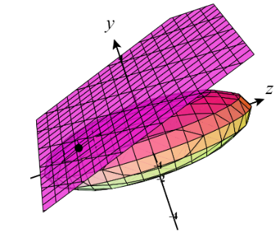
- has a nonvertical tangent plane at the point .
- can be approximated by a linear function for points near .
- is continuous at .

The following definition allows for our desired extension to take place. Details of how this concept may be explored/discovered are shown in more detail in the notes on Blackboard.

Definition: A function f of two variables is said to be differentiable at provided and both exist and

Note: A similar extension exists for functions of three variables. To see an explanation of the derivation of this idea consult page 942 of the textbook.

Note: Intuitively, this means that the linearization of f at (a,b) does a good job of approximating f near (a,b). As such, we can understand that a surface being differentiable loosely mean that the tangent plane exists and does a nice job of modeling the surface near the point of tangency.

Note: The expressions subtracted in the numerator may be seen as a multiplication of matrices’, which will become of great importance if one wishes to further extend the notion of differentiability to n-dimensional spaces. We will see how this idea of matrices can be used when we discuss the Jacobian in section 4.7.
Theorem: If a function is differentiable at a point , then it is continuous at that point.

Proof: See page 943 of the textbook.

Note: This is a great result which shows us that we are able to extend the notion of differentiability in the way we desired!

It can be very difficult to use the above definition to determine whether a two or three variable function is differentiable at a point. This leads us to the following more useful theorem.

Theorem: If all first-order partial derivatives of f exist and are continuous at a point, then is differentiable at that point.

Proof: Beyond the scope of the course.

Note: This theorem applies to functions with any number of variables!

Example 1: Is the function differentiable at .

